Introduction
Section 7.2.8 of Saddington Parish Neighbourhood Plan describes Local Views that are considered to be important to the character of Saddington.  Consultation during the Neighbourhood Plan’s preparation identified a widely-held wish to protect Saddington’s rural setting, and its relationship with the surrounding farmland and the wider landscape, including its position in a gap between high ground to the west and east and the wide Welland valley to the south. Residents expressed this wish was by describing a number of highly-valued views within the village and toward it from the surrounding countryside. These consultation findings were supported by the environmental inventory which also confirmed the sight- lines of the suggested views and mapped them.  Neighbourhood Plan Policy ENV 8 is intended to provide protection to the six important views that shown on the figure and listed below by careful siting of all development in the parish during the lifetime of the Plan.  1. Views south to northwest from field 093 and Mowsley Road/Saddington Hall at the western edge of the village over extensive open countryside.  2. Views northeast to east from field 026 into the village and over open countryside toward Fleckney, mainly grassland with hedges and trees.  3. Views east and southeast from various publicly accessible locations (including public house garden) over the valley of Langton Brook and an ornamental lake with wooded banks (parcel 136) and Saddington Reservoir (172) to the high ground marking the southern parish boundary.  4. Panoramic views northwest to east from field 037 into east Leicestershire, Northamptonshire, etc., over the canal and open countryside.  5. Views north and east from field 165 and Mowsley Road over the Langton Brook valley toward Saddington village (northwards) and the reservoir and open countryside (east).  6. View southeast from footpath A.14 across valley meadows to the hillside incorporating fields 151 and 152.  Photographs of each view are provided to depict the natural beauty and characteristics that are valued by residents of Saddington and visitors to Saddington. | 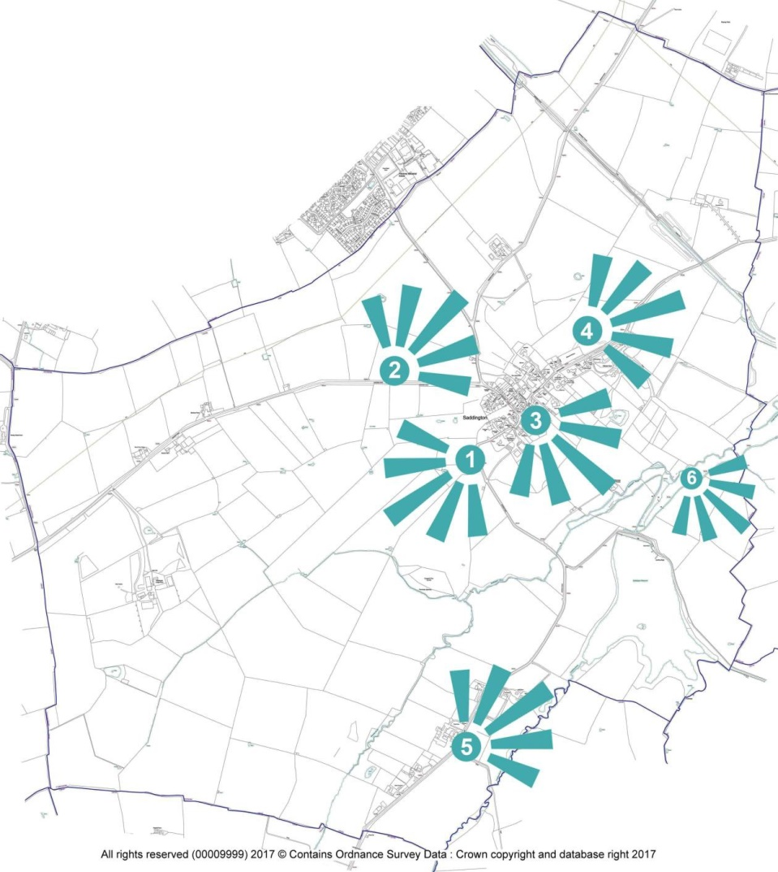  Views that are Considered to be Important to Saddington

1. Views south to northwest from field 093 and Mowsley Road/Saddington Hall at the western edge of the village over extensive open countryside
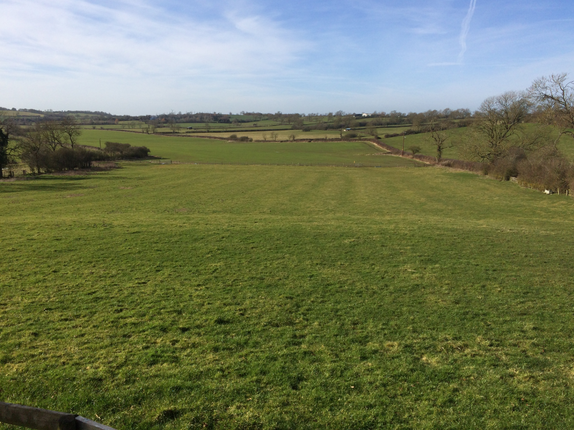
2. Views northeast to east from field 026 into the village and over open countryside toward Fleckney, mainly grassland with hedges and trees
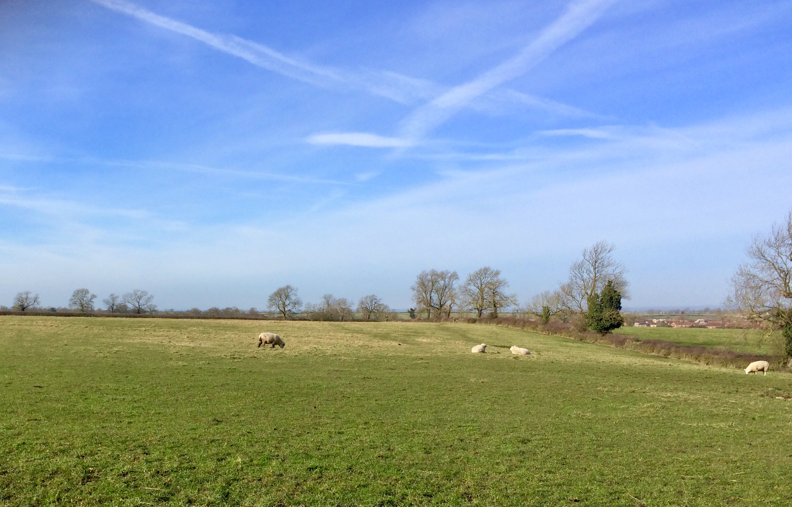
3. Views east and southeast from various publicly accessible locations (including public house garden) over the valley of Langton Brook and an ornamental lake with wooded banks (parcel 136) and Saddington Reservoir (172) to the high ground marking the southern parish boundary
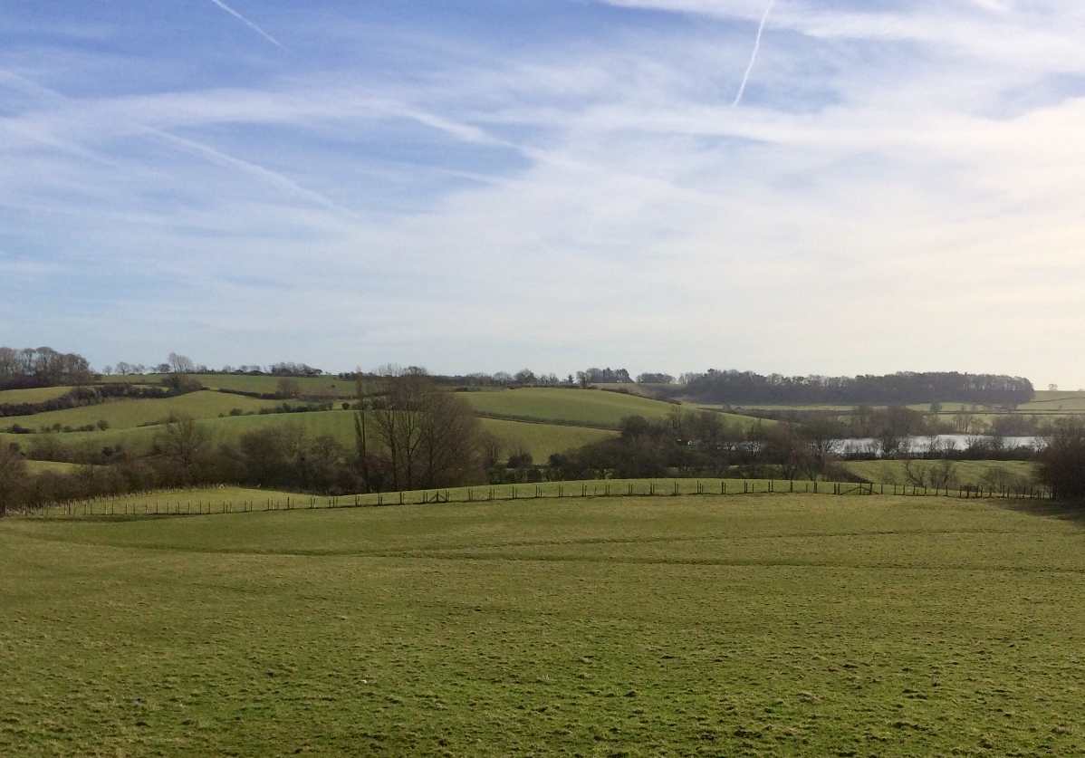
4. Panoramic views northwest to east from field 037 into east Leicestershire, Northamptonshire, etc., over the canal and open countryside
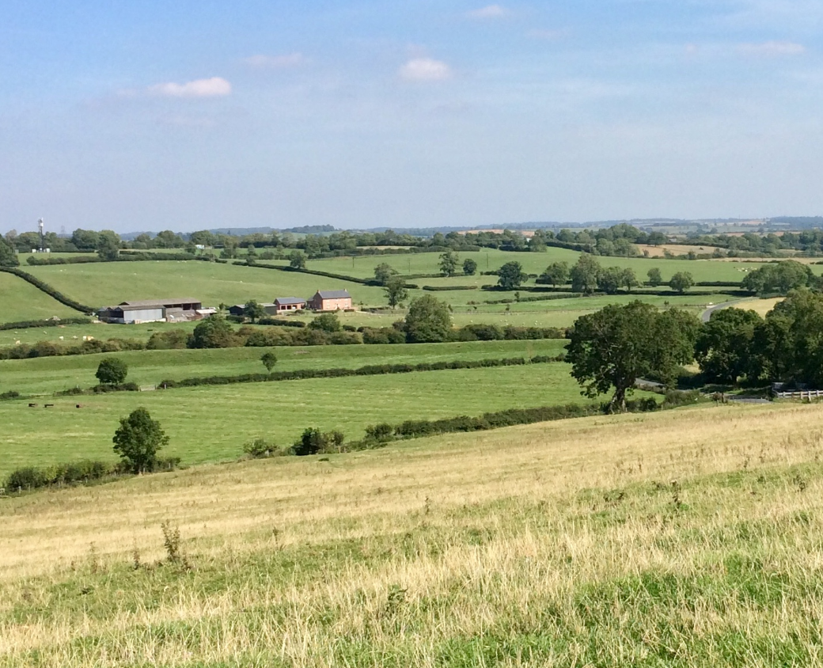
5. Views north and east from field 165 and Mowsley Road over the Langton Brook valley toward Saddington village (northwards) and the reservoir and open countryside (east)
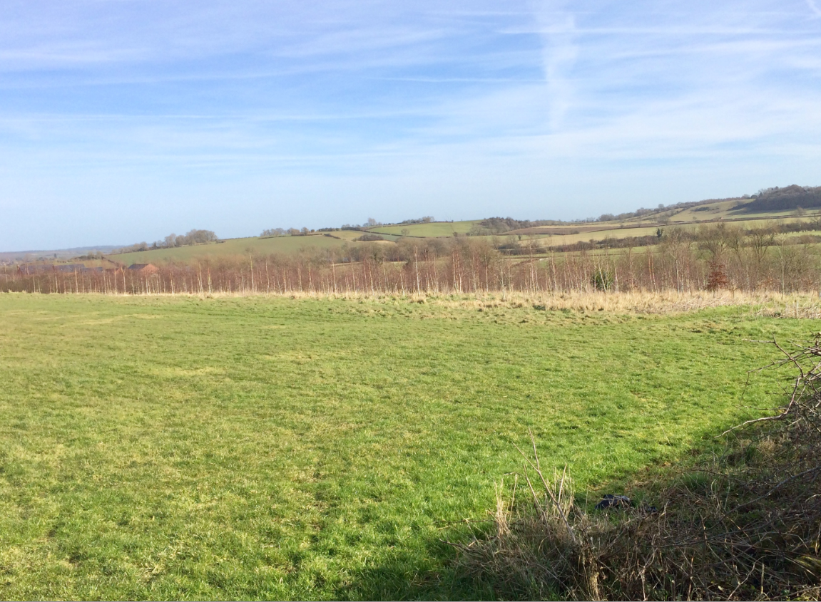
6. View southeast from footpath A.14 across valley meadows to the hillside incorporating fields 151 and 152
